University of Abertay
MSc Computer Science

Module: HCS513
Future Challenges
Report

By Rebecca Burns

Word Count - 4249
Introduction – 289
Critical Appraisal – 1411
Proposal – 1210
Evaluation – 1339

- Introduction

Climate change is intensifying environmental pressures across the globe, driving warmer, drier conditions that significantly increase the likelihood and severity of wildfires. In the United Kingdom, rising temperatures and prolonged dry spells have altered seasonal patterns, contributing to a wildfire activity (Baker et al, 2025). Recent analyses show two distinct peaks in the UK wildfire season: a spring peak in March and April, fuelled by decaying winter vegetation, and a summer peak associated with higher temperatures and extended periods of low rainfall (Mackay et al, 2021)(Belcher et al, 2023). These shifts demonstrate how climate change is transforming the frequency, intensity, and unpredictability of wildfire events across the country.
In 2025, the worst year for wildfires was recorded in the UK, fire and rescue services in England and Wales responded to almost 1,000 wildfires (NFCC, 2025) with a total of 47,879 hectares burnt across the UK (McShane, 2026), highlighting the growing pressure on emergency response services and mitigation plans (NFCC, 2026) The scale of the problem is particularly evident in peatland regions. Peatlands represent only a fraction of the land affected by fire, however they account for up to 90% of the UK’s fire-driven carbon emissions due to the large quantities of carbon stored within peat soils (Baker et al, 2025).
These environmental and social challenges frame UK wildfires as a wicked problem, characterised by complex issues, contrasting stakeholder interests, and resistance to simple solutions (Rittel and Webber, 1973). Addressing this challenge requires innovative approaches that strengthen preparedness and model climate-driven fire behaviour under realistic UK conditions. This report critically examines the complexities of UK wildfires and proposes a virtual reality (VR) simulation tool designed to enhance decision making and resilience in future wildfire scenarios for emergency responders.

- Critical Appraisal

Complexity across different domains
UK wildfires are deeply entwined with four core domains: climate systems, ecological and environmental conditions, human activity, and socio-economic structures. Each domain contains numerous sub-domains that interact in complex and unpredictable ways. This entanglement positions UK wildfires as a multi-dimensional wicked problem that resists simple solutions.

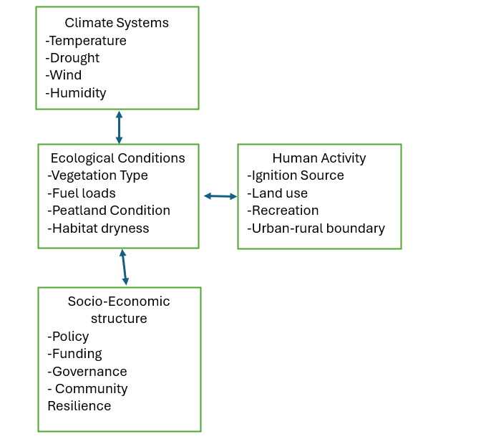
Figure 1. illustrates how the four domains interconnect to create a complex, multi-layered system of wildfire risk in the UK.
Wildfire behaviour and climate impacts
The nature, frequency and severity of these events vary by scale and are shaped by a combination of climate change, peatland dryness, vegetation fuel loads, land-management practices, and human ignition sources, creating a complex system where causes and consequences continually change (Barber-Lomax et al, 2022). This complexity makes wildfire behaviour unpredictable, particularly in UK where peatlands can release large quantities of stored carbon. Peatland wildfires have a significant impact on the climate. It is estimated between 2001 and 2021, peatland fires caused by wildfires released an estimated 800,000 tonnes of carbon (Baker et al, 2025). Peatland wildfires have the capacity to nearly double global fire-driven carbon emissions, and the carbon released can take centuries to be restored (Baker et al, 2025). This emission release directly undermines Net Zero targets directly impacting climate change.
Limitation in current mitigation and public engagement
Forestry England supports Fire and Rescue Services during wildfire incidents and uses prescribed burning as part of its land-management strategy, which aligns with recognised mitigation practices. However, its focus on face-to-face public engagement presents clear limitations. High visitor (over 363 million per year April 2021-2022) numbers across forests and recreation sites make regular, meaningful engagement difficult to achieve, and signposts and notices highlighting dangers alone cannot influence behaviour at this scale (Forestry England, n.d.). A similar pattern is seen within the Forestry Commission, where public-facing efforts appear to rely on simple awareness campaigns delivered through social media, such as encouraging visitors to take litter home or restrict barbecues to designated areas. Although the Commission provides Lantra-accredited training for staff to develop incident-scenario preparedness, there is no equivalent training for the public (Forestry Commission, 2026.). This demonstrates that public awareness approaches are present, but they remain insufficient when compared to the current rising scale of wildfire risk stemming from human actions.
Sparse data
The UK does not maintain a specific wildfire dataset just for wildfires, instead, wildfire incidents are mingled into all fire categories, making the data fragmented, sparse, and often misleading for analysis. UK wildfire data remains inconsistent across different sources, national datasets do not classify wildfires as a distinct incident type, regional datasets only capture specific landscapes, and satellite products detect heat rather than verified wildfire events. As a result, UK wildfire analysis relies on partial datasets that require significant interpretation and filtering (NFCC, 2024).
Stakeholders and competing interests
Wildfires in the UK have competing interests across conservation groups, rural communities, agricultural landowners, fire services, and government bodies. Each group holds different values, risk perceptions, and resource constraints, often leading to disagreements (Gazzard et al, 2016).
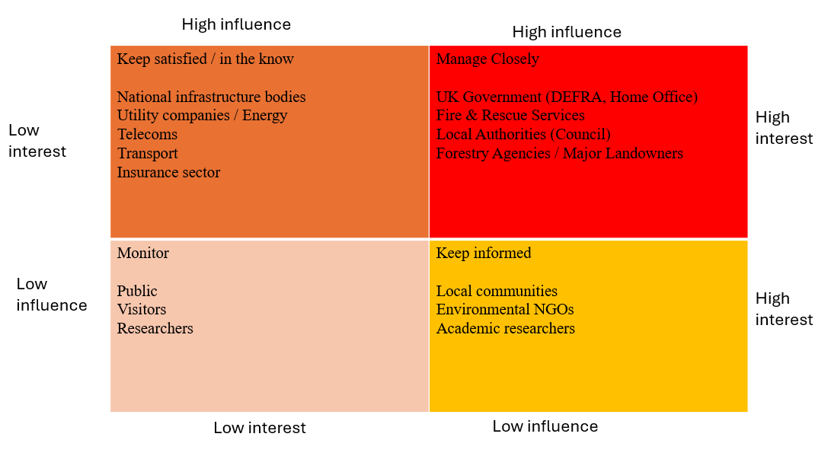
Figure 2. Stakeholder influence map showing competing interests in UK Wildfire Management
The stakeholder influence map shows how different groups shape UK wildfire management. High-influence organisations such as Fire and Rescue Services, government bodies and major landowners drive policy and operational decisions. Medium-influence groups, including environment organisations, infrastructure operators and agricultural sectors, support land management and risk reduction. Low-influence groups, such as residents and recreational users, experience the greatest impacts but have limited input in decisions. These relationships expose overlapping and competing priorities, making wildfire management a complex multi-agency challenge.
The Paradox – Rapid Emergency Response vs long term resilience
One conflict within UK wildfire management is the need to deliver rapid emergency response whilst adapting long term resilience.
Rapid Emergency Response | Long Term Resilience
Protect people | Public awareness
Protect infrastructure | Reduce fuel loads through landscape management
Protect natural environment | Restore natural habitats  (Peatland, heathland, biodiversity)
Early detection from spreading further | Firebreaks and strategic land planning
Clear command hierarchy | Multi stakeholder and long-term commitment

Table 1. Comparison of rapid response and long-term resilience requirements in UK wildfire management
Another important factor that affects this conflict is the vulnerability of the UK’s urban–rural boundary, sometimes referred to as Wildland Urban interface (WUI) or rural-urban interface (RUI) where housing and burnable vegetation meet and wildfire exposure increases (Maille et al, n.d). At this boundary over 1.8 million homes lie within 100 metres of high-risk edges (Ordnance Survey, 2025). The boundary is described as highly fragmented, forming a patchwork of housing, farmland, scrub, and unmanaged dry vegetation (DEFRA, 2026). This mix creates uneven wildfire exposure and combined with dense human activity it is critical rapid response and long-term resilience operate work together.
Landscape Variation
A further dataset that reinforces this conflict is the vegetation based wildfire analysis by Lees, Davies and Lenton (2026). Their study demonstrates that wildfire size, severity and timing vary significantly with dominant vegetation types across England and Wales. Molinia-dominated landscapes tend to produce larger but lower-severity fires, whereas heather-dominated areas generate smaller but higher-severity fires due to woody fuel loads. This variability means emergency services must prepare for rapid response under different fire behaviours, while long-term resilience planning must account for different landscape structures and ecological restoration needs. The dataset highlights that resilience needs to be approached to adapt the different patchwork of vegetation types that shape UK wildfire regimes.
Although the vegetation-severity dataset by Lees, Davies and Lenton (2026) provides insight into fire behaviour across England and Wales, similar datasets do not currently exist for Scotland. Instead, Scottish wildfire evidence is drawn from incident data published by the Scottish Fire and Rescue Service (SFRS, 2022), habitat and fuel-type mapping from NatureScot (NatureScot, 2026), and regional wildfire risk assessments produced by the Scottish Wildfire Forum (Scottish Wildlife Forum 2024).
These datasets highlight Scotland’s distinct vegetation profile, including extensive blanket bog, upland heath and Caledonian pine forests, which behave differently under wildfire conditions. As a result, severity modelling in Scotland cannot rely solely on weather-based tools such as the Fire Severity Index, which is produced by the Met Office and does not incorporate vegetation or fuel structure (Met Office, 2024).
Fire Severity Index (FSI)
A further consideration is the Fire Severity Index (FSI), which evaluates how severe a wildfire could become under current weather conditions, using factors such as rainfall, drought, wind speed, temperature and humidity (Met Office, 2025). While the FSI provides a UK-wide assessment of potential fire behaviour, it does not account for local vegetation, despite vegetation being a major driver of fire severity. As demonstrated by Lees, Davies and Lenton (2026), wildfire size and severity vary significantly between Molinia grasslands, heather-dominated moorlands and mixed heathland. Given the UK’s patchwork landscape, the FSI must be interpreted alongside local ecological data to ensure that severity assessments reflect the fuel conditions present at each location.
In wildfire-prone regions such as California, firebreaks are widely implemented. However, the UK’s rural–urban boundary does not have firebreaks in place. Instead, vegetation such as grassy verges, scrub and farmland often sits directly beside roads, powerlines and other critical infrastructure, increasing both ignition likelihood and disruption risk (Emergency Services Times, 2025). It is important to note that England does have firebreaks, but these are limited to upland peatlands, dry heath, and designated conservation sites (Game and Wildlife Conservation Trust, 2025).
Furthermore, recent wildfire disasters in California demonstrate that even well-established firebreak strategies do not always prevent large-scale, high-severity events. This supports the evidence that firebreaks alone cannot stop a wildfire, their effectiveness depends heavily on local vegetation, topography, fuel continuity and fire-weather conditions, and they must be integrated into broader landscape-level fire management rather than used as stand-alone defences (Zong et al., 2026).
International adoption
International frameworks are most useful when they help the UK anticipate future climate conditions or highlight long-term policy gaps, but they must be adapted to reflect the UK’s unique landscape structure (Convery-Fisher and Parkins, 2026). An important factor identified in recent research is the communication challenges associated with public warning systems, particularly communication fatigue or the cry-wolf effect, where repeated or poorly timed alerts lead to declining public responsiveness. Evidence from international studies shows that recreationists and residents in high-risk regions such as California often become less interested to wildfire warnings when they are issued too frequently or without clear relevance (Budzyn et al, 2026). The same effect is well documented in Australia and is considered a significant problem for wildfire risk communication (Ewart and Heinrichs Henry, 2025).
Overall, the evidence demonstrates that UK wildfire risk emerges from a deeply interconnected system where climate pressures, ecological conditions, human behaviour and socio-economic structures continually interact. Current mitigation efforts, public engagement strategies and national datasets provide partial support but remain misaligned with the scale and complexity of contemporary wildfire behaviour. Landscape variation, fragmented stakeholder priorities and limitations in severity assessment tools further constrain effective planning. Taken together, these factors show that UK wildfire management requires a shift from reactive, weather-driven approaches toward integrated, landscape-specific, and socially informed resilience strategies.

- Technological Solution Proposal
The proposed technological solution is a VR wildfire emergency response simulation tool designed to address the paradox identified in the Critical Appraisal. Although human activity is well documented as the primary ignition source for UK wildfires (NFCC, n.d), public engagement with prevention remains limited with current communication approaches often seasonal and lacking wider public understanding (Beadle,2026). As a result, emergency response continues to operate at the forefront and must function effectively when preventative measures fail. Therefore, a VR emergency response simulation tool offers a way to bridge this gap by enabling immersive, scenario-based training that prepares responders for rapid decision-making while also supporting long-term landscape understanding, fuel awareness, and strategic resilience planning.
Fully developed VR wildfire simulators are limited, but VR is already used extensively in California for firefighter training, particularly for structural fires and wildland–urban interface (WUI) incidents. These systems demonstrate how immersive simulation can enhance hazard recognition, situational awareness and decision making under pressure. The proposed VR solution adapts these principles to the UK wildfire context, integrating vegetation-specific fire behaviour, rural–urban interface risk and long-term resilience planning.
Spatial mapping technologies already exist within VR systems, particularly for indoor environments where surfaces, geometry and user movement can be captured in real time (Li, 2024). However, landscape-scale spatial mapping for wildfire terrain is far less developed, with VR applications facing recognised challenges in model construction and spatial direction when applied to complex environments (Wiltenburg et al, 2024). Existing tools such as GIS datasets, digital twins and VR wildfire training used in California provide partial terrain modelling, but they do not incorporate UK-specific vegetation mosaics, fuel structures or rural–urban interface fragmentation. This gap strengthens the case for a VR solution that integrates spatial mapping with ecological data, enabling responders to visualise topography, fuel loads and fire behaviour within a realistic UK landscape.
International examples further support this approach. A YouTube video published by UNSW (2024) demonstrates an AI-driven bushfire simulator developed by the iCinema Research Centre to train New South Wales firefighters. The system immerses responders in dynamic, landscape fire scenarios, improving hazard recognition, anticipation of fire behaviour and decision making under pressure in safe environment. This provides a similar representation for the proposed UK VR solution, showing how immersive simulation can enhance both rapid emergency response and long-term resilience planning.
A similar approach is also used operationally in California, where firefighters train for wildland–urban interface (WUI) incidents using immersive VR systems. A news clip published by KPIX CBS News Bay Area (2024) shows crews rehearsing dynamic wildfire scenarios in virtual environments to improve situational awareness, hazard recognition and decision-making under pressure. This further demonstrates that VR is already being deployed internationally as a practical emergency-response tool, reinforcing the relevance and feasibility of the proposed UK solution
The proposed VR wildfire emergency response simulation tool would include dynamic environmental and behavioural features, enabling users to explore how different conditions influence fire behaviour. Key interactive elements would include adjustable wind direction and speed, variable weather scenarios (such as drought, high humidity or heatwaves), and diverse vegetation types with differing fuel loads. A built-in compass and spatial orientation tools would support situational awareness, allowing users to understand how landscape position and wind alignment affect fire spread. Additional features such as terrain slope, fuel moisture levels and ignition source selection would further enhance realism and support both operational and strategic training objectives.

Feature Overview
The VR wildfire simulation incorporates a structured set of interactive features that allow users to explore how environmental, behavioural and natural and built landscape conditions influence fire behaviour. These features are designed to support both operational decision-making and long-term resilience planning by enabling users to manipulate key variables and observe their effects within a realistic UK landscape model. Core features include dynamic environmental controls (wind, temperature, visibility, weather scenarios), spatial orientation tools (compass, slope, fire-front direction), and ecological parameters (vegetation type, fuel load, moisture levels). Together, these features create an immersive training environment that enhances hazard recognition, situational awareness under pressure.
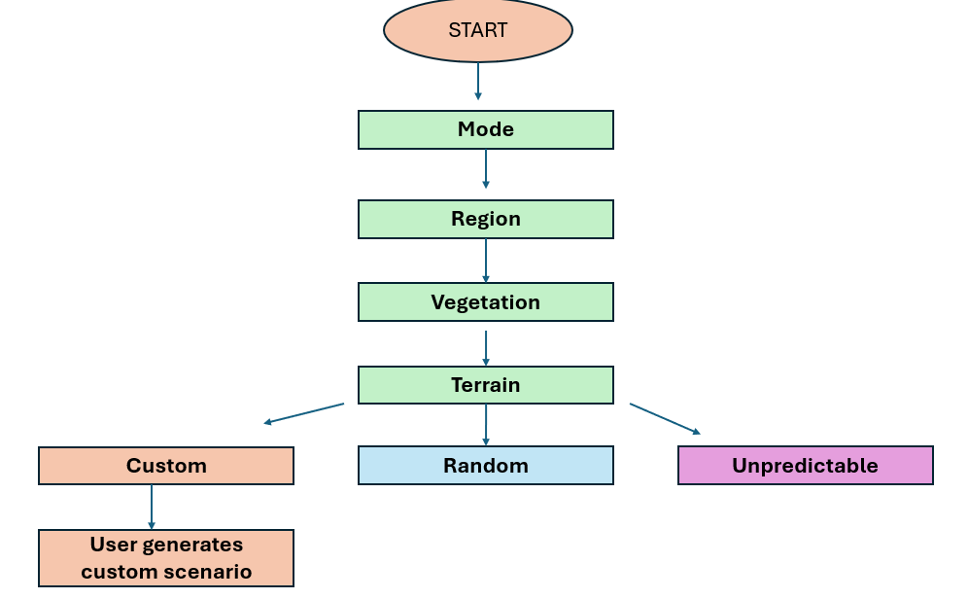

Figure 3 Scenario generation flowchart
After selecting scenario parameters through the mode, region, vegetation and terrain interfaces, users interact with the following icon-based tools to explore and manipulate wildfire behaviour.
Figure 4. Scenario mode selection interface.

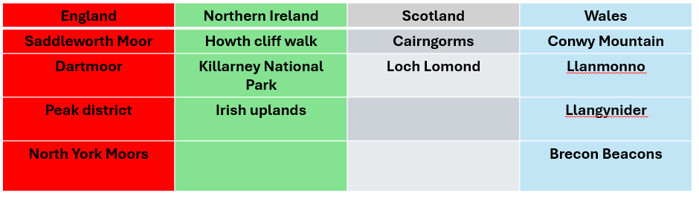
Figure 5. Region selection interface (England, Northern Ireland, Scotland, Wales).


Figure 6. Vegetation selection interface

Figure 7. Terrain selection interface
Alternatively, the user can interact with a fire risk map and hoover over a location where there will be details
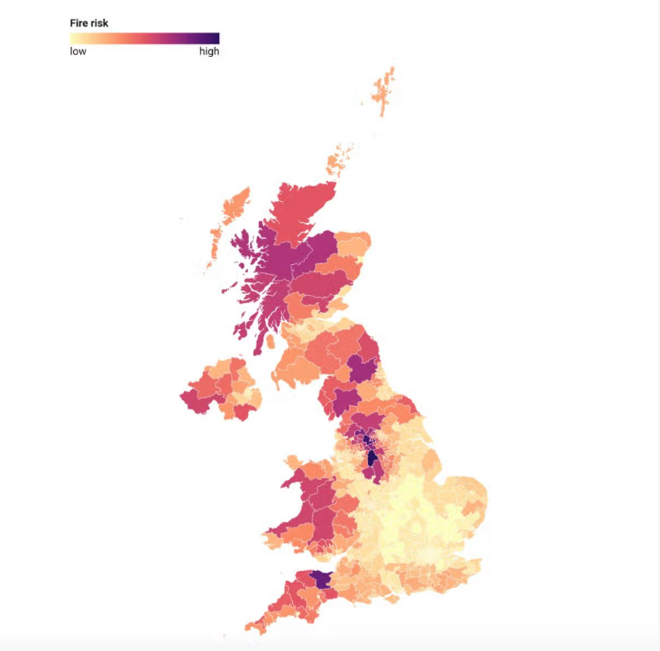

Figure 8 UK fire-risk map showing regional variations in wildfire danger (Ault and McGrath, 2026).
Figure 8 is included as an example of how wildfire risk can be visualised. In the proposed design, a similar interactive map using appropriate UK wildfire datasets would be created, enabling users to hover over specific locations to reveal information.
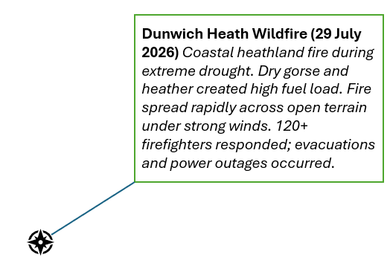

Figure 9. Hover-over interaction example.
When the user hovers over a location on the map, the interface displays contextual information such as vegetation type, terrain form, fuel load, and risk level.
Icons are used throughout the interface to support cognitive ease, reducing the mental effort required for users to interpret information during high-pressure wildfire scenarios. Visual symbols allow rapid recognition, minimise reading load, and help users process environmental conditions and scenario controls more efficiently than text alone. This is particularly important in emergency response contexts, where responders must make quick decisions and cannot afford cognitive overload. By using simple, intuitive icons, the interface enhances situational awareness, supports faster information processing, and aligns with established Human Factors principles for low-effort visual communication.

Environmental Conditions Icons

Icon | Environmental Condition | Function | User Interaction
 | Day / Night | Controls lighting conditions that influence visibility, perception, and environmental behaviour. | User toggles between day and night to observe changes in visibility and environmental response.
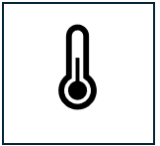 | Temperature | Temperature of replicate real-life scenario | User increases or decreases temperature using a slider to simulate heat-related changes.
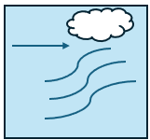 | Wind movements | Shows wind direction and intensity affecting scenario dynamics and environmental spread. | User toggles wind speeds and direction.
 | Visibility  Fog  Smoke | Represents visibility impacting user awareness and scenario interpretation | User modifies visibility level using slider (clear  moderate  low) to understand how perception changes

Table 2. Environmental Condition Icons for user interface
The Environmental Conditions category represents the core physical variables that shape wildfire behaviour within the simulation. These icons allow users to manipulate factors such as temperature, wind direction, visibility, and lighting conditions, each of which directly influences fuel dryness, fire spread rate, and situational clarity. By adjusting these parameters, users can observe how small environmental changes create significant operational challenges, such as reduced visibility from smoke or accelerated fire movement under strong winds. This category supports hazard recognition by helping users understand how dynamic environmental conditions interact with terrain and fuel loads, reinforcing the importance of environmental monitoring in real-world wildfire response.
Observation and behaviour icons
Icon | Observation / Behaviour | Function | User interaction
 | Aerial View | User gets aerial view to scan the area | User switches to aerial view
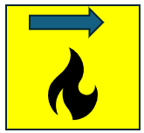 | Fire Spread Direction | User predicts or observes | Shows predicted or observed fire direction based on wind.
 | Wildlife Monitoring / Observations | User encounter  Ecological behaviour | Highlights wildlife movement patterns that may indicate disturbance, early warning signs
 | Binoculars  Safety glasses | Observation -  User can click to wear binoculars or safety glasses | Visual scanning  that supports detailed inspection of the landscape

Table 3 Observation and Behaviour icons for user interface
The Observation & Behaviour category contains tools that enhance situational awareness and support environmental scanning. These icons represent observational aids such as aerial views, wildlife behaviour cues, binoculars, and glare reduction tools. Together, they help users interpret subtle environmental signals that may indicate emerging hazards, such as wildlife displacement or reduced visibility. This category emphasises the role of active observation in wildfire management, enabling users to identify risks earlier, track fire movement more accurately, and understand how behavioural indicators contribute to decision-making. By integrating both human and ecological cues, the simulation encourages users to adopt a multi-layered approach to situational awareness.
Infrastructure and Ignition Icons
Icon |  | Function | User interaction
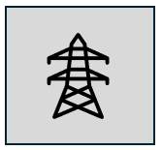 | Infrastructure  Pylon | Represents built infrastructure vulnerable to ignition | User identifies infrastructure risk points.
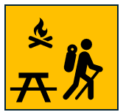 | Ignition source point / human activity | Represents human-caused ignition. | User selects ignition source to simulate fire start.

Table 4 Infrastructure and Ignition Icons for user interface
The Infrastructure & Ignition category highlights the interaction between human activity, built structures, and wildfire risk. Icons in this section represent ignition sources (such as campfires) and vulnerable infrastructure (such as pylons, overhead lines), helping users explore how anthropogenic factors contribute to fire outbreaks and escalation. This category reinforces the importance of identifying ignition points, assessing infrastructure exposure, and understanding how human presence can amplify wildfire hazards. By allowing users to simulate ignition scenarios and evaluate infrastructure vulnerability, the interface supports resilience planning and encourages proactive risk mitigation strategies.

Orientation and Scenario icon
Icon |  | Function | User interaction
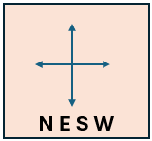 | Compass | Displays real-time wind direction and fire spread direction | Users visually track how wind shifts influence fire movement.
 | Clock / Time | Shows the simulation time and supports time-based scenario progression. | Users observe how fire behaviour evolves over time.
 | Stopwatch | Measures elapsed time for specific user-triggered events (e.g fire spread) | Users start/stop/reset the timer to track how quickly conditions change
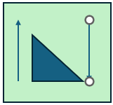 | Slope gradient | Displays the gradient at the user’s selected location, showing how steepness influences wildfire spread rate and flame behaviour. | Supports scenario testing by allowing users to compare fire behaviour across flat ground, rolling hills, and steep uplands.
 | Record | Captures the user’s session, including environmental changes, decisions, and outcomes | User presses Record button before starting the scenario to capture their full decision-making process
 | Replay / Playback | Allows users to re-watch their recorded scenario with slow down speed up option to review decisions, identify mistakes, and evaluate alternative strategies | User selects Replay button to watch their recorded session and analyse where they would make different choices

Table 5 Orientation and Scenario Icons for user interface
The Orientation & Scenario Controls category provides users with navigational tools and scenario-management functions that support decision-making under pressure. Icons such as the compass, slope indicator, fire-front direction, and time controls help users interpret spatial relationships and anticipate fire movement across varied terrain. To assess and reflect on the session record and replay functions enhances reflective learning by allowing users to capture their decision-making process and review it afterwards to identify strengths, mistakes, and alternative strategies. This category ensures users can navigate the scenario effectively, manage temporal progression, and engage in iterative learning.

Evaluation and Limitations

System Strengths
The VR wildfire emergency response simulation tool provides an effective and immersive environment for exploring how wildfire dynamics affect environmental conditions and different landscapes. Its interactive controls and spatial tools support hazard recognition and decision making by allowing users to manipulate variables and observe their effects in real time, including record and replay functions. The system demonstrates how changes in wind, slope, vegetation, and fuel continuity alter fire behaviour, helping users build situational awareness and understand the complexity of wildfire spread in a safe environment. By enabling users to adjust environmental parameters and observe immediate outcomes, the simulation reinforces the importance of environmental monitoring and supports strategic learning.
The icon-based interface further strengthens usability by supporting cognitive ease. Icons allow rapid recognition, and minimise the mental effort required to interpret complex environmental information during high-pressure scenarios. This design choice aligns with human-factors principles and ensures that users can focus on decision-making rather than interface navigation. The structured icon system also supports consistency across different scenario modes, making the interface appealing for both experienced responders and new trainees.
Feasibility
The feasibility of the proposed VR solution is supported by existing technologies already used in emergency response training. VR is widely adopted in California for structural and wildland–urban interface (WUI) firefighting, demonstrating that immersive hazard environments can enhance situational awareness and decision-making (KPIX CBS News 2024). Spatial mapping technologies, digital twins, and GIS datasets provide a foundation for modelling terrain, vegetation, and fuel loads (Wiltenburg, 2024). Although landscape-scale spatial mapping is still developing, the integration of ecological datasets, vegetation maps, and terrain models makes the proposed system technically achievable.
The simulation design also enhances feasibility. With environmental controls, vegetation types, and scenario parameters that can be added or updated without redesigning the entire system. This allows the tool to evolve alongside new datasets, climate conditions, and training requirements. The record and replay functions are feasible using existing VR capture tools, and the icon-based interface can be implemented using standard UI frameworks within VR development platforms.
However, feasibility is constrained by the fragmented nature of UK wildfire data. National datasets do not classify wildfires as a distinct incident type, regional datasets vary in scope, and satellite products detect heat rather than confirmed wildfire events. These gaps limit the accuracy of severity modelling and may reduce the realism of simulated fire behaviour, particularly in regions where vegetation data is incomplete. For example, while vegetation severity datasets exist for England and Wales, equivalent data for Scotland is limited, requiring reliance on habitat mapping and regional assessments.
Scalability
The proposed VR system is highly scalable due to its mixed structure. New regions, vegetation types, and scenario modes can be integrated as additional datasets become available. This allows the simulation to expand across England, Scotland, Wales, and Northern Ireland, reflecting the UK’s diverse landscape structures and wildfire behaviours. The system can also scale across organisations, including Fire and Rescue Services, land management agencies, environmental bodies, and educational institutions.
Scalability also applies to long-term resilience planning. By modelling landscape variation, rural–urban interface fragmentation and fuel load differences, the tool can help planners explore strategies such as firebreak placement, habitat restoration and fuel load reduction (Barber-Lomax et al, 2022)( Zong et al, 2026). As it currently stands, it leans more towards the emergency-response direction, but as it expands it can take a dual-focus approach which directly addresses the paradox identified in the Critical Appraisal and positions the VR tool as a bridge between operational and strategic wildfire management.
However, scalability is limited and VR hardware may not be accessible to all relevant parties, particularly smaller fire services or community groups. Widespread adoption requires investment in equipment, training, and maintenance. Public engagement applications may also face accessibility barriers, as not all users are familiar with VR technology or comfortable using immersive systems.
Educational Limitations
VR training environments cannot fully replicate real-world conditions such as heat, smoke, fatigue, or reduced visibility, all of which are known to influence decision-making during wildfire incidents (UNSW, 2024). Although the simulation provides a safe and immersive learning environment, the absence of physical stressors means users operate without the pressures faced by responders in real life. As a result, user behaviour within the simulation may differ from real-world decision-making, particularly in high-pressure or time-critical situations.
Recent research shows that multisensory VR systems can significantly improve realism and behavioural accuracy. For example, Robot Fire integrates heat and smoke cues using an robotic arm, enabling trainees to perceive fire direction and intensity more effectively. Participants located fire sources more accurately and with lower workload compared to visual-only VR training, demonstrating that multisensory cues improve situational awareness and hazard interpretation. This suggests that adding thermal and olfactory elements could enhance the effectiveness of future wildfire training environments by providing more realistic sensory feedback (Chen et al. 2024).
User Experience Limitations
The controlled nature of the VR environment removes constraints such as smoke inhalation, disorientation, limited visibility, and physical exertion. These factors significantly shape situational awareness during live wildfire events, meaning the simulation cannot fully replicate the sensory complexity of operational response. The interface also relies on basic icons, which may limit the full understanding of landscape interpretation and may oversimplify complex environmental features. Although icons support cognitive ease, they may reduce the depth of environmental detail available to the user, requiring careful design to ensure they accurately represent underlying processes.
Technical Limitations
VR systems capable of detailed terrain modelling and dynamic environmental simulation are expensive, which may limit accessibility for smaller organisations. Weather modelling also presents challenges. Tools such as the Fire Severity Index provide useful indicators but do not incorporate vegetation structure, meaning simulated severity may not always reflect real-world conditions (Wiltenburg, 2024).
Privacy, Security and AI Ethics
Privacy and security concerns in VR are well documented, particularly in relation to the extensive behavioural and biometric data captured by immersive systems. VR headsets routinely collect motion patterns, gaze behaviour, spatial mapping data and environmental imagery, all of which can be used to infer identity, behaviour and sensitive personal information. Research shows that VR/AR platforms face cybersecurity threats including data theft, observation attacks, weak authentication and unauthorised access to sensor streams, creating risks that extend beyond simple user tracking. These vulnerabilities raise ethical concerns around user autonomy, informed consent and the potential misuse of behavioural analytics, especially when immersive systems capture more data than users realise (Giaretta, 2024).
Privacy remains a structural limitation of VR-based training tools. Although the proposed wildfire simulation operates within a wider VR ecosystem where behavioural signals can be exploited for identification or behavioural identification attacks with high accuracy, these risks are inherent to VR platforms rather than the simulation itself. They highlight the need for careful data handling and transparent privacy practices. Any deployment of the proposed wildfire simulation must therefore incorporate strict data-minimisation principles, clear privacy policies, secure data-handling procedures and strict ethical guidelines to ensure responsible use (Giaretta, 2024).
Conclusion
Wildfire behaviour across the UK is shaped by varied landscapes, fragmented vegetation and incomplete datasets, creating ongoing challenges for both emergency response and long-term planning. Weather-based tools such as the Fire Severity Index provide useful indicators, but they do not account for vegetation structure, fuel continuity, or fine-scale landscape characteristics, limiting their ability to represent the complexity of UK wildfire regimes. The VR wildfire simulation developed in this project helps address part of this gap by offering an accessible and immersive environment for exploring how environmental conditions, terrain and fuel types influence fire spread. While it cannot replicate real-world stressors or model detailed ecological processes, it remains a valuable educational tool that strengthens hazard awareness, supports scenario exploration and encourages proactive risk assessment. Future development could integrate live meteorological feeds, more detailed fuel datasets and expanded ecological modelling to improve realism and support both incident response and strategic resilience planning. Overall, the simulation demonstrates how spatially informed, interactive technologies can contribute meaningfully to UK wildfire preparedness, with particular relevance for emergency response training in a landscape where traditional datasets and modelling tools remain limited.

References
Ault, R. and McGrath, C. (2026) ‘UK wildfires mapped as 3 regions purple with risk of devastating blaze’, Daily Express, 31 July. Available at: https://www.express.co.uk/news/uk/2234784/uk-wildfires-mapped-3-regions (Accessed: 9 October 2026).
Baker, S.J., Perry, M.C., Betts, R.A., Schoenecker, J. and Pellegrini, A.F.A. (2025) 'Spikes in UK wildfire emissions driven by peatland fires in dry years' Available at: https://iopscience.iop.org/article/10.1088/1748-9326/adafc6/pdf (Accessed: 10 September 2026).
Barber-Lomax, A., Battye, R., Gibson, S., Castellnou, M. and Bachfischer, M. (2022) Peak District National Park wildfire risk assessment: full report. Peak District National Park Authority. Available at: https://www.peakdistrictwildfire.co.uk/_files/ugd/9c9ad7_a594c151525a4878a241bac12e93d409.pdf (Accessed: 20 September 2026).
Belcher, C.M., Brown, I., Clay, G.D., Doerr, S.H., Elliott, A., Gazzard, R., Kettridge, N., Morison, J., Perry, M., Santín, C. and Smith, T.E.L. (2021) UK wildfires and their climate challenges: expert-led report prepared for the Third UK Climate Change Risk Assessment (CCRA3). Available at: https://www.researchgate.net/publication/352569211_UK_Wildfires_and_their_Climate_Challenges (Accessed: 20 September 2026).
Budzyn, E.E., Zwickle, A. & Perry, E.E. (2026) ‘Burnt out on wildfire warnings: quality messages drive recreationists’ safety, but overload backfires’, Journal of Risk Research. (Accessed 3 October).
Chen, J., Fu, S., Liao, Z., Xiao, X., Qu, H. and Lv, J. (2024) RobotFire: A Multisensory VR Simulator for Fire Training with Robot-Assisted Smoke and Temperature Simulation. Proceedings of the 17th International Symposium on Visual Information Communication and Interaction. Available at: https://doi.org/10.1145/3678698.3687173 (Accessed 22 October 2026).
Convery-Fisher, E. and Parkins, K. (2026) Wildfires: what can the UK and other nations learn from Australia's world-leading fire response systems? 24 July. Available at Wildfires: What can the UK and other nations learn from Australia's world-leading fire response systems? (Accessed 2 0ctober 2026).

DEFRA (2026) Don't spark disaster: changing public behaviour as UK wildfire risk grows Available at Don’t spark disaster: changing public behaviour as UK wildfire risk grows – Environment (Accessed 30 September 2026).
Emergency Services Times (2025) Location data key to tackling Britain's growing wildfire threat. Available at: https://emergencyservicestimes.com/2025/08/15/location-data-key-to-tackling-britains-growing-wildfire-threat (Accessed: 3 October 2026).
Ewart, J. and Heinrichs Henry, D. (2025) Communication gaps in Australian disasters: a review of Australian disaster inquiries recommendations about public communication from 2003 to 2023. Available at: https://www.researchgate.net/publication/393050092_Communication_Gaps_in_Australian_Disasters_A_Review_of_Australian_Disaster_Inquiries_Recommendations_About_Public_Communication_From_2003_to_2023 (Accessed 4 October 2026).
Forestry Commission. (2026) Managing wildfire risk: how the Forestry Commission responds. Available at: https://forestrycommission.blog.gov.uk/2026/07/15/managing-wildfire-risk-how-the-forestry-commission-responds (Accessed 27 September 2026).
Forestry England (n.d) Record visit numbers show we are a nation that our forests more. Available at Record visit numbers show we are a nation that love our forests more! | Forestry England (Accessed 27 September 2026).
Forestry England (n.d) The threat of wildfires to the nations forest. Available at How Forestry England prevents and responds to wildfires | Forestry England (Accessed 27 September 2026).
Game and Wildlife Conservation Trust (2025) The role of firebreaks to prevent, mitigate and control wildfire on deep peat and dry heath is acknowledged by Natural England. Available at: https://www.gwct.org.uk/blogs/news/2025/august/the-role-of-firebreaks-to-control-wildfire-is-acknowledged-by-natural-england (Accessed 3 October 2026).
Gazzard, R., McMorrow, J. & Aylen, J. (2016) ‘Wildfire policy and management in England: an evolving response from Fire and Rescue Services, forestry and cross-sector groups. Available at (PDF) Wildfire policy and management in England: an evolving response from Fire and Rescue Services, forestry and cross-sector groups (Accessed 28 September 2025).
Giaretta, A. (2024) Security and privacy in virtual reality – a literature survey. Available at Security and Privacy in Virtual Reality - A Literature Survey. (Accessed 22 October 2026).
KPIX CBS News Bay Area (2024) Virtual reality training helping California firefighters prepare for wildfires. Available at: Virtual reality training helping California firefighters prepare for wildfires (Accessed 3 October 2026).
Lees, K.J., Davies, G.M. & Lenton, T.M. (2026) ‘Wildfire size, severity and timing vary with dominant vegetation in open landscapes in England and Wales. Available at Wildfire size, severity and timing vary with dominant vegetation in open landscapes in England and Wales - Lees - 2026 - Ecological Solutions and Evidence - Wiley Online Library (Accessed 27 September 2026).
Li, X. (2024) Design and Optimization of Urban Spatial Environment Based on Digital Intelligent VR Technology.: https://www.sciencedirect.com/science/article/pii/S1877050924020982 (Accessed 23 October 2026).
Marfella, L., Glanville, H.C., Niccoli, F., Wilby, R.L. and Smith, D. (2026) 'Public perceptions of wildfire risk in the UK: a study of Roaches Nature Reserve in the Peak District', Available at: https://www.mdpi.com/2073-445X/15/6/944 (Accessed 28 September 2026).
Maillé, E., Casula, F. & Alcasena, F. (n.d.) Wild fire risk in the rural–urban interface. Academia.edu. Available at: https://www.academia.edu/16359156/Wild_fire_risk_in_the_rural_urban_interface (Accessed: 29 September 2026).
McShane, M. (2026) Wildfire statistics UK: record fires, causes and trends 2026. Fire Safety Awareness Training. Available at: https://firesafetyawarenesstraining.co.uk/blog/wildfire-statistics-uk (Accessed: 14 September 2026).
Met Office (2025) Fire Severity Index (FSI): understanding wildfire conditions in the UK. Available at: Fire Severity Index (FSI) – Understanding Wildfire Conditions in the UK - Met Office (Accessed 26 September 2026).
National Fire Chiefs Council (NFCC (2024) Wildfires position statement. Available at Wildfires position statement - NFCC. (Accessed 18 September 2026)
National Fire Chiefs Council (NFCC) (2025) New wildfire record sparks urgent call for fire service investment. Available at: https://nfcc.org.uk/new-wildfire-record-sparks-urgent-call-for-fire-service-investment/ (Accessed 18 September 2026).
National Fire Chiefs Council (NFCC) (2026) Wildfires are placing growing pressures on firefighters and emergency response, warn Fire chiefs. Available at Wildfires are placing growing pressure on firefighters and emergency response, warn Fire Chiefs - NFCC (Accessed: 18 September 2026)
National Fire Chiefs Council (NFCC) (n.d.) Wildfire Aware. Available at: https://nfcc.org.uk/our-services/campaigns/wildfire-aware. (Accessed 7 October)
NatureScot (2026) SAC Discussion Paper: Wildfire and Muirburn Impacts and Creating Resilient Landscapes. Available at https://www.nature.scot/sites/default/files/2026-03/sac-discussion-paper-wildfire-and-muirburn-impacts-and-creating-resilient-landscapes.docx. (Accessed 27 September 2026).
Ordnance Survey (2025) How location data supports wildfire preparedness across Britain. Available at: https://www.ordnancesurvey.co.uk/insights/how-location-data-supports-wildfire-preparedness-across-britain (Accessed 26 September 2026).
Rittel, H.W.J. and Webber, M.M. (1973) 'Dilemmas in a general theory of planning', Policy Sciences, 4(2), pp. 155–169. Available at: Rittel & Webber, 1973: Dilemmas in a General Theory of Planning (Accessed 18 September 2026).
Scottish Government (2022) Scottish Fire and Rescue Service (SFRS) – Wildfire: Incident Reporting System (IRS) Data Analyses. Available at: https://www.gov.scot/publications/provision-analyses-scottish-fire-rescue-service-sfrs-incident-reporting-system-irs-data-relation-wildfire-incidents (Accessed 14 October 2026).
Scottish Wildfire Forum (2024) Resources. Available at https://www.scottishwildfireforum.co.uk/resources (Accessed: 27 September 2026).
UK Parliament POST (2023) Wildfire risks to UK landscapes. Available at: https://researchbriefings.files.parliament.uk/documents/POST-PN-0717/POST-PN-0717.pdf (Accessed: 25 September 2026).
UNSW (2024) Bushfire simulator that’s training our firefighters. YouTube video, uploaded by UNSW. Available at: https://www.youtube.com/watch?v=1woqOLfV8wM (Accessed: 3 October 2026).
Wiltenburg, R., Ruiz Mendoza, F., Hurst, W. & Tekinerdogan, B. (2024) Virtual Reality for Spatial Planning and Emergency Situations: Challenges and Solution Directions. Applied Sciences, 14, 3595
Zong, X., Wang, X., Coogan, S.C.P. and Flannigan, M.D. (2026) 'Effectiveness of firebreaks: a review' Available at: https://www.nwfirescience.org/sites/default/files/publications/s42408-026-00451-1.pdf (Accessed: 3 October 2026).

